OurCade Database

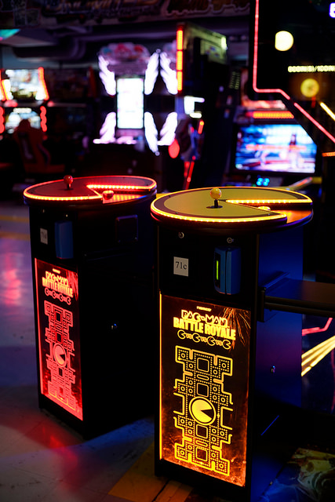

**Anthony Harris**

**Database Management Systems**

**Robert Perkoski**

**December 2017**

Table of Contents

Introduction… Page 3

E-R Model… Page 4

Business Rules… Page 5

Attribute

Descriptions… Page 6

Question List… Page 9

Closing… Page 13

Introduction

This project is based off of a concept for a local arcade that I came up with while taking INFSCI 1052 (User-Centered Design) this past summer. A link to the webpage can be found here: <http://pitt.edu/~agh34/1052/HarrisMidterm>. OurCade is meant to be a small business that specializes in classic arcade games and Japanese imports. This establishment also sponsors tournaments and joint events with other local establishments to enhance the social gaming experience.

This database was built to track the monetary success of the growing number of games at OurCade. Additionally, this database manages the various interactions between the store and its vendors. This data can be turned into knowledge that can determine business decisions (such as which machines to keep, promote, or sell). Because the arcade machines are often imported, the database will also be able to apply country-based conditions to determine trends. Lastly, the database is partially-indexed so that users can more quickly search tables such as game, by name rather than by id.

OurCade is targeted towards students and adults looking for alternative group activities, as well as gamers of all ages. Internally the database lends itself to executive and financial officers making inventory and promotional-based decisions. The knowledge that can be interpreted from this database wouldn’t provide much for day-to-day operations, but could prove instrumental for long-term success.

E-R Model

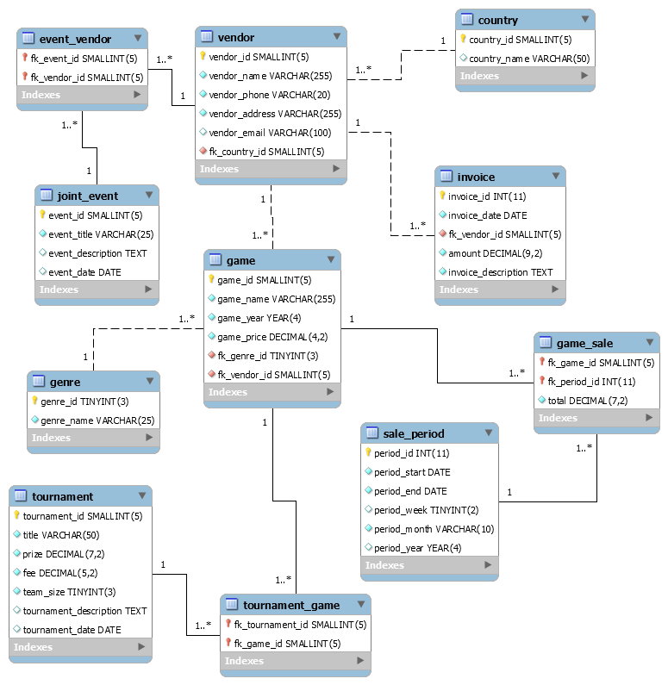

**Note: I could not find an underline feature for Workbench to use on Primary Keys.**

**Note: I could not figure out how to change the multiplicity for relevant relationships to 0..\***

Business Rules

|  |  |  |  |  |
| --- | --- | --- | --- | --- |
| **Entity 1** | **Entity 2** | **Cardinality on Entity 1 side** | **Cardinality on Entity 2 side** | **Business Rule(s)** |
| Game | Genre | 1..* | 1 | A game may have only one genre.  A genre must be associated with one or more games. |
| Game | Vendor | 0..* | 1 | A game is produced by only one vendor.  Some vendors are event-based so they may be credited with many or no games. |
| Game | Period | 1..* | 1..* | A game’s sales are documented during at least one period. A period documents at least one game. (Junction Table: game_sale) |
| Game | Tournament | 1..* | 0..* | A game can feature in none or many tournaments. A tournament must feature at least one game. (Junction Table: tournament_game) |
| Vendor | Country | 1..* | 1 | A vendor is based in only one country. One country contains one or more vendors. |
| Vendor | Invoice | 1 | 1..* | One vendor appears on at least one invoice. An invoice describes an interaction with only one vendor. |
| Vendor | Joint Event | 1..* | 0..* | A vendor can participate in none or many events. A single joint event must feature at least one vendor. (Junction Table: event_vendor) |

Entity/Attribute Descriptions

|  |  |  |
| --- | --- | --- |
| **genre** | | |
| (pk) genre_id | TINYINT(3) | The primary identification number of the genre. |
| genre_name | VARCHAR(25) | The name of the genre. |
| **game** | | |
| (pk) game_id | SMALLINT(5) | The primary identification number of the game. |
| game_name | VARCHAR(255) | The full name of the game. |
| game_year | YEAR(4) | The original year the game was produced. |
| game_price | DECIMAL(4,2) | The cost to play one round of the game. |
| (fk) genre_id | TINYINT(3) | The genre of the game given by a list. |
| (fk) vendor_id | SMALLINT(5) | The producer of the game. |
| **vendor** | | |
| (pk) vendor_id | SMALLINT(5) | The primary identification number of the vendor. |
| vendor_name | VARCHAR(255) | The name of the vendor. |
| vendor_phone | VARCHAR(20) | The phone number for the vendor. Can accommodate international numbers |
| vendor_address | VARCHAR(255) | The shipping address for the vendor. |
| vendor_email | VARCHAR(100) | The primary email of the vendor representative. |
| (fk) country_id | SMALLINT | The country of origin of the vendor. |
| **country** | | |
| (pk) country_id | SMALLINT(5) | The primary identification number of the country. |
| country_name | VARCHAR(50) | The name of the country. |
| **invoice** | | |
| invoice_id | INT(11) | The primary identification number of the invoice. |
| invoice_date | DATE | The date of the transaction. |
| amount | DECIMAL(9,2) | The absolute value of the transaction. |
| invoice_description | TEXT | The nature of the transaction (buying, selling, etc.) |
| (fk) vendor_id | SMALLINT(5) | The participant of the transaction. |
| **sale_period** | | |
| (pk) period_id | INT(11) | The primary identification number of the period. |
| period_start | DATE | The first day of the chosen period. |
| period_end | DATE | The last day of the chosen period. |
| period_week | TINYINT(2) | Optional week identifier. Resets every business year. |
| period_month | VARCHAR(10) | The name of the month the period takes place. |
| period_year | YEAR(4) | The year of the period takes place. |
| **game_sale** | | |
| (pk)(fk) game_id | SMALLINT(5) | The game half of the composite key. |
| (pk)(fk) period_id | INT(11) | The period half of the composite key. |
| **tournament** | | |
| (pk) tournament_id | SMALLINT(5) | The primary identification number of the tournament |
| title | VARCHAR(50) | The title of the tournament. |
| prize | DECIMAL(7,2) | The prize amount for winning the tournament. |
| fee | DECIMAL(5,2) | The entry fee of the tournament. |
| team_size | TINYINT(3) | The required size of team entering the tournament. |
| tournament_description | TEXT | An overview of the tournament. |
| **tournament_game** | | |
| (pk)(fk) tournament_id | SMALLINT(5) | The tournament half of the composite key. |
| (pk)(fk) game_id | SMALLINT(5) | The game half of the composite key. |
| **joint_event** | | |
| (pk) event_id | SMALLINT(5) | The primary identification number of the event. |
| event_title | VARCHAR(25) | The title of the event. |
| event_description | TEXT | A brief description of the event. |
| event_date | DATE | The date of the event. |
| **event_vendor** | | |
| (pk)(fk) event_id | SMALLINT(5) | The event half of the composite key. |
| (pk)(fk) vendor_id | SMALLINT(5) | The vendor half of the composite key. |

Question List

1. **What was the least popular game last month?**

SELECT game_name, period_month, total

FROM game a JOIN game_sale b

ON a.game_id = b.game_id

JOIN sale_period c

ON c.period_id = b.period_id

WHERE total in (SELECT MAX(total)

FROM game_sale);

* 1. **This question allows the user to make promotional decisions based on what customers are (or are not) putting their money towards.**

1. **Which country produces most of Ourcade’s games?**

SELECT vendor_id, country_name

FROM vendor b JOIN country c

ON c.country_id = b.country_id

WHERE vendor_id = (SELECT vendor_id

FROM game

GROUP BY vendor_id

ORDER BY COUNT(vendor_id) DESC

LIMIT 1);

* 1. **This question allows the user to gain insight on Ourcade’s partnerships.**

1. **What is the average price to play a round of a game at OurCade?**

SELECT AVG(game_price)

FROM game;

* 1. **This knowledge also allows the user to make comparisons with competitors based on pricing.**

1. **How many machines were added to the roster between June and December?**

SELECT FLOOR(COUNT(*) - ((SELECT COUNT(*)

FROM game_sale a JOIN sale_period b

ON a.period_id = b.period_id

WHERE period_month = 'June') / 4)) AS Total

FROM game_sale a JOIN sale_period b

ON a.period_id = b.period_id

WHERE period_month = 'December';

* 1. **This query allows the user to measure growth in the company.**

1. **What were the fees for tournaments with average prizes?**

SELECT title, prize, tournament_date, fee

FROM tournament

WHERE prize IN (SELECT prize

FROM tournament

HAVING AVG(prize));

* 1. **With this answer we can make a determination about the quality of tournament prizes.**

1. **What were the 5 most expensive transactions so far, descending?**

SELECT invoice_date, vendor_id, amount, invoice_description

FROM invoice

ORDER BY amount DESC

LIMIT 5;

* 1. **This answer allows users to see where large expenditures are coming from**.

1. **Which genre is the most popular?**

SELECT game_name, genre_name

FROM genre d JOIN game a

ON d.genre_id = a.genre_id

JOIN game_sale b

ON a.game_id = b.game_id

JOIN sale_period c

ON c.period_id = b.period_id

WHERE total in (SELECT MAX(total)

FROM game_sale);

* 1. **This knowledge provides guidance in the process of promotion and asset acquisition.**

1. **Which vendors have not yet participated in an event?**

SELECT vendor_name

FROM vendor

WHERE vendor_name NOT IN (SELECT DISTINCT vendor_name

FROM vendor a JOIN event_vendor b

ON a.vendor_id = b.vendor_id

JOIN joint_event c

ON c.event_id = b.event_id);

* 1. **This allows OurCade to make decisions down the road about future events and evaluate current partnerships trends.**

1. **Which game has not yet been featured in a tournament?**

SELECT game_name

FROM game

WHERE game_name NOT IN (SELECT DISTINCT game_name

FROM game a JOIN tournament_game b

ON a.game_id = b.game_id

JOIN tournament c

ON c.tournament_id = b.tournament_id);

* 1. **This allows OurCade to make decisions down the road about upcoming tournaments and evaluate current customer trends.**

1. **What was the most profitable month recorded so far?**

SELECT period_month, total

FROM game_sale b JOIN sale_period c

ON c.period_id = b.period_id

WHERE total in (SELECT MAX(total)

FROM game_sale);

* 1. **With this insight, OurCade users can better evaluate performance.**

Closing

Working on this project was a valuable lesson in scope-creep. In the attempt to exceed expectations, I wound up with tables with too many rows, which lead to junction tables that required that many more insert statements, and table relationships that needed to be redefined as the deadline drew closer. However, I can say that there was probably no better way for me to get intimate with Workbench’s functionality. Furthermore, time spent researching errors and questions dropped significantly over the course of this project. The lessons I learned and the skills I developed, during the creation of this database, will really come into play next semester when I tackle my capstone project in Web Programming. Thanks for the semester.